3.7 Configure Log4j in Eclipse Maven Project



This section will guide you to:

* Configure Log4j in Eclipse Maven project

**Development Environment:**

* Eclipse IDE
* Java 1.8

This guide has four subsections, namely:

3.7.1 Creating a Maven project

3.7.2 Updating the pom.xml file with Log4j dependencies

3.7.3 Testing the application with BasicConfigurator

3.4.7 Pushing the code to GitHub repositories

**Step 3.7.1:** Creating a Maven Project

* Open Eclipse.
* Click on File---> New--->Project.
* Select the Maven project and click on Next.
* Enter the Group id and Artifact id and click on Finish.

**Step 3.7.2:** Updating the pom.xml file with log4j dependencies

* Open the pom.xml file.
* Add the dependencies given below to pom.xml file:

<dependency>

<groupId>log4j</groupId>

<artifactId>log4j</artifactId>

<version>1.2.17</version></dependency>

**Step 3.7.3:** Testing the application with BasicConfigurator

* Create a package **com.employeeapi** inside the src/main/java directory.
* Create a class **LogTest.java** inside the package **com.employeeapi.**
* Write the code given below to test the logger:

**package** com.employeeapi;

**import** org.apache.log4j.BasicConfigurator;

**import** org.apache.log4j.Logger;

**public** **class** LogTest {

**static** **final** **Logger** logger =

**Logger**.getLogger(LogTest.class);

**public** **static** void main(**String**[] args)

{

//Configure logger

BasicConfigurator.configure();

logger.debug("Hello World!");

}

}

* Run the Java application and verify the output.

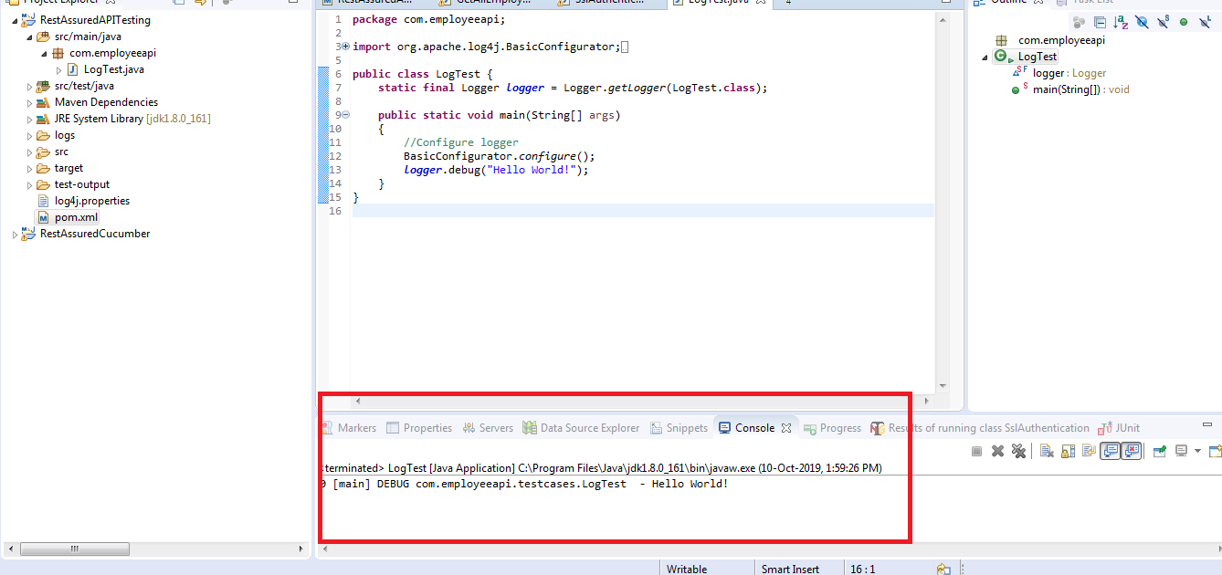

**Step 3.7.4:** Pushing the code to GitHub repositories

Open your command prompt and navigate to the folder where you have created your files.

cd <folder path>

Initialize your repository using the following command:

git init

Add all the files to your git repository using the following command:

git add . 

Commit the changes using the following command:

git commit . -m “Changes have been committed.”

Push the files to the folder you initially created using the following command:

git push -u origin master